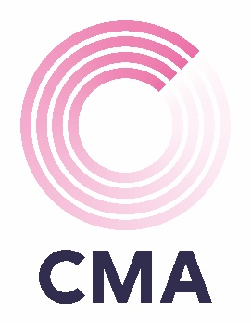

Team Registration Form

CMA Charity Quiz
Thursday 19 March 2026

5:30pm Arrival
Portsmouth Football Club

The cost per team is £120 for a team of 6 including food which is to be pre-ordered in advance.

As you are aware this is a charity event and we would really appreciate a prize donation, big or small, that could be raffled or auctioned. You can bring these along with you on the night, or we can arrange to collect them from your place of work.

Menu Choices:

- Pie & Chips
- Vegetarian curry with rice

Team Name:
Main Contact:
Team Member:  Food Order: | Team Member:  Food Order:
Team Member:  Food Order: | Team Member:  Food Order:
Team Member:  Food Order: | Team Member:  Food Order:

Due to the popularity of the event and in order to secure your team’s place, payment is requested by Friday 6 March 2026.

Please make payment via BACS directly to CMA Financial Recruitment Ltd using sort code 40-42-18 and account number 84015827. Please quote ref: Ports Quiz Company Name.

