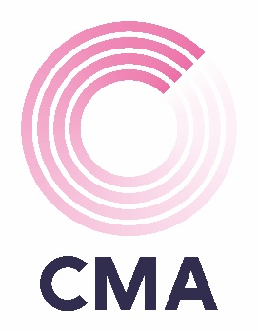

TEAM REGISTRATION FORM

CMA CHARITY QUIZ
Thursday, 21st March 2024

Portsmouth Football Club
6.00pm Arrival

Main Contact:
Team Name:
Team Member:  Food Order: | Team Member:  Food Order:
Team Member:  Food Order: | Team Member:  Food Order:
Team Member:  Food Order: | Team Member:  Food Order:

The cost per team is £80 for a team of 6 and £60 for a team of 4 (including food which is to be pre-ordered in advance).

The maximum team is 6 members, if you would like to enter multiple teams, please get in touch with your CMA contact directly.

As you are aware this is a charity event and we would really appreciate a prize donation, big or small, that could be raffled or auctioned. You can bring these along on the night, or we can arrange to collect them from your place of work. We are also asking for donations of new toiletries or clothes which can be donated to Stop Domestic Abuse.

Menu Choices:

Pie & Chips
Vegetarian curry with Rice

Due to the popularity of the event and in order to secure your team’s place, payment is requested by Friday 1st March 2024.

Please make payment via BACS directly to CMA Financial Recruitment Ltd using sort code 40-42-18 and account number 84015827. Please quote ref: Ports Quiz Company Name.



